Bit Advanced labs

2.Learn to host a static website (such as a personal portfolio) on Amazon S3.

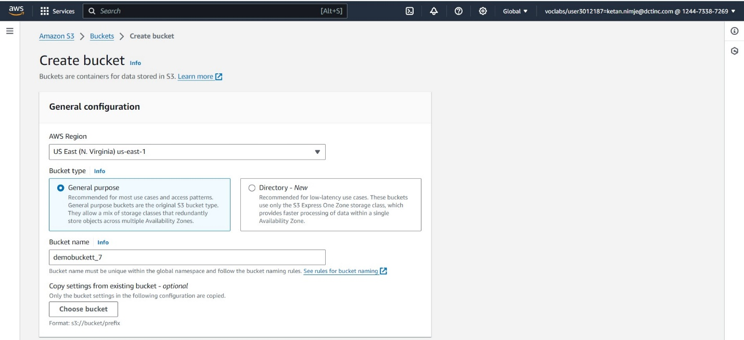

Creating a S3 bucket and adding the website file in the bucket

Editing the static website hosting settings

Editing the bucket policy

Generating the policy for bucket

By clicking on the above link, we can access static website as shown below.

1.Learn how to create a scalable and highly available web application environment using Amazon EC2 instances, ELB, and ASG.

Creating two security groups one for internet access and one for client

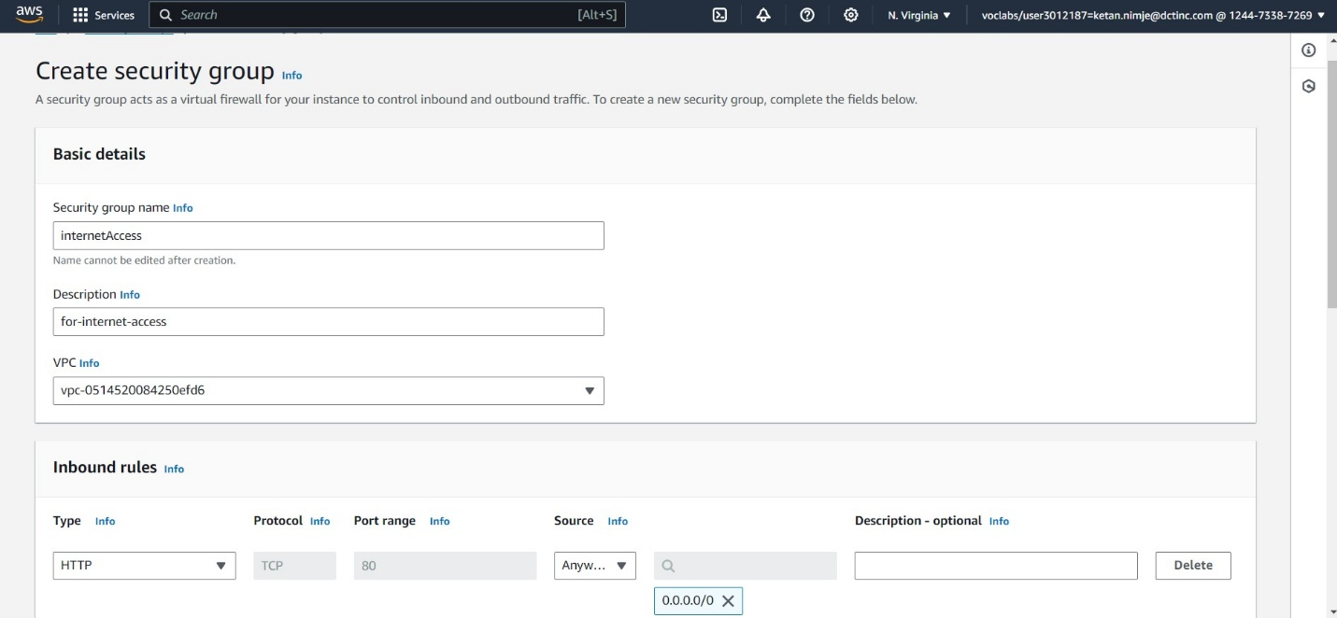

Launch 2 instances for our group and check whether they are running or not

For both the instances commands are same just change to the respective IPv4 address.

Both instances are running





Create target group for our instances.

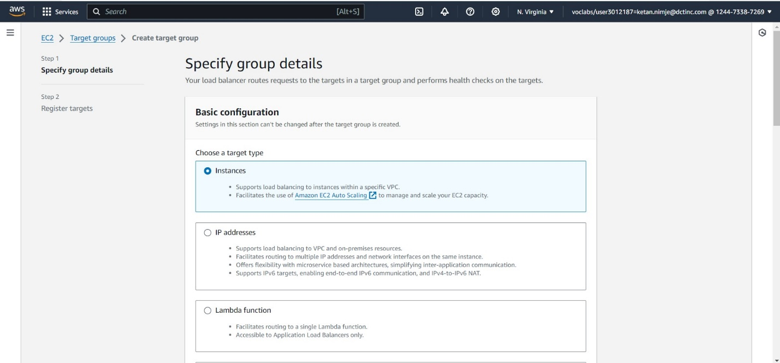

Creating a load balancer

This is the output: running load balancer using the load balancer dns

Creating image for instances

Creating template for auto scaling group

Creating auto scaling group

This is the required output i.e. created an auto scaling group and checked whether the instance is displaying same result

